**MICROPROCESSOR LAB**

**LAB 1**

| **Study of PC Motherboard Technology (South Bridge and North Bridge). Internal Components and Connections used in Computer System** |
| --- |

**1) Describe the motherboard with a diagram.**

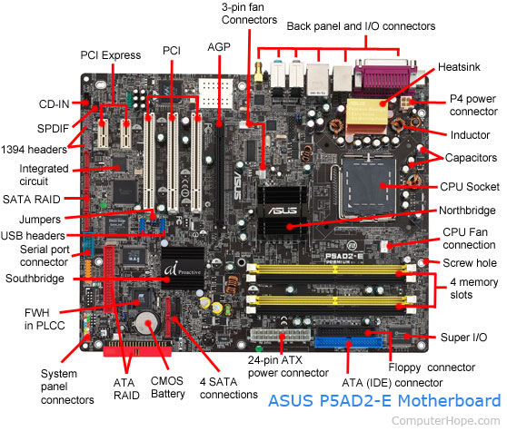

**2) Difference between Northbridge and Southbridge.**

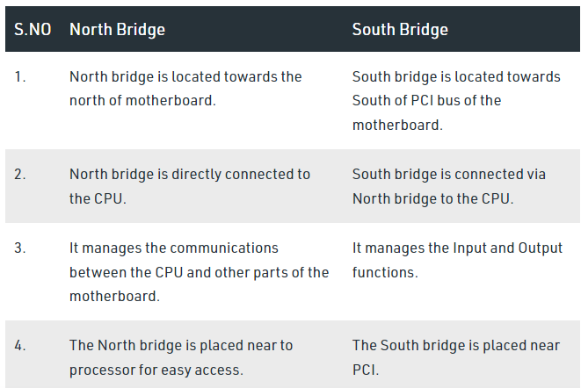

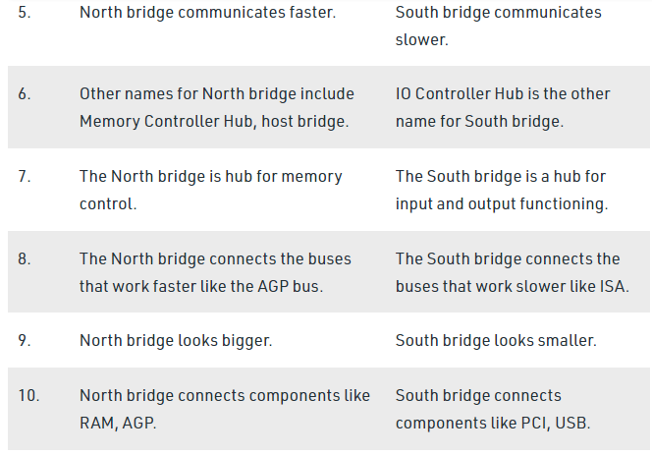

**3) Other components of the motherboard.**

* **1. Mouse & keyboard:** Keyboard Connectors are basically two types. All PCs have a Keyboard port connected directly to the motherboard. The oldest, but still quite common type, is a special DIN, and most PCs until recently retained this style connector. The AT-style keyboard connector is quickly disappearing, being replaced by the smaller mini DIN PS/2-style keyboard connector.
* You can use an AT-style keyboard with a PS/2-style socket (or the other way around) by using a converter. Although the AT connector is unique in PCs, the PS/2-style mini-DIN is also used in more modern PCs for the mouse. Fortunately , most PCs that use the mini-DIN for both the keyboard and mouse clearly mark each mini-DIN socket as to its correct use. Some keyboards have a USB connection, but these are fairly rare compared to the PS/2 connection keyboards.
* **2. USB (Universal serial bus):**  USB is the General-purpose connection for PC. You can find USB versions of many different devices, such as mice, keyboards, scanners, cameras, and even printers. a USB connector's distinctive rectangular shape makes it easily recognizable.
* USB has a number of features that makes it particularly popular on PCs. First, USB devices are hot swappable. You can insert or remove them without restarting your system.
* **3. Parallel port:** Most printers use a special connector called a parallel port. Parallel port carry data on more than one wire, as opposed to the serial port, which uses only one wire. Parallel ports use a 25-pin female DB connector. Parallel ports are directly supported by the motherboard through a direct connection or through a dangle.
* **4. CPU Chip :** The *central processing unit,* also called the *microprocessor* performs all the calculations that take place inside a pc. CPUs come in Variety of shapes and sizes.
* Modern CPUs generate a lot of heat and thus require a cooling fan or heat sink. The cooling device (such as a cooling fan) is removable, although some CPU manufactures sell the CPU with a fan permanently attached.
* **5. RAM slots:** Random-Access Memory (RAM) stores programs and data currently being used by the CPU. RAM is measured in units called bytes. RAM has been packaged in many different ways. The most current package is called a 168-pin DIMM (Dual Inline Memory module).
* **6. Floppy controller:** The floppy drive connects to the computer via a 34-pin *ribbon cable,* which in turn connects to the motherboard. A *floppy controller* is one that is used to control the floppy drive.
* **7. IDE controller:** Industry standards define two common types of hard drives: EIDE and SCSI. Majority of the PCs use EIDE drives. SCSI drives show up in high end PCs such as network servers or graphical workstations. The EIDE drive connects to the hard drive via a 2-inch-wide, 40-pin ribbon cable, which in turn connects to the motherboard. *IDE controller* is responsible for controlling the hard drive.
* **8. PCI slot:** Intel introduced the *Peripheral component interconnect* bus protocol. The PCI bus is used to connect I/O devices (such as NIC or RAID controllers) to the main logic of the computer. PCI bus has replaced the ISA bus.
* **9. ISA slot:**  (Industry Standard Architecture) It is the standard architecture of the Expansion bus. Motherboard may contain some slots to connect ISA compatible cards.

**10. CMOS Battery:** To provide CMOS with the power when the computer is turned off all motherboards come with a battery. These batteries mount on the motherboard in one of three ways: the obsolete external battery, the most common onboard battery, and built-in battery.

**4) Different types of connections in the motherboard.**

Computer systems use various types of connections to communicate and transfer data between different components. Some of the most commonly used connections in computer systems are:

USB: Universal Serial Bus (USB) is a standard connection used to connect devices like keyboards, mice, printers, external hard drives, and other peripherals to a computer.

Ethernet: Ethernet is a wired connection used to connect computers and other devices in a local area network (LAN) or to connect a computer to the internet.

Wi-Fi: Wi-Fi is a wireless connection that uses radio waves to connect devices to a network, allowing them to access the internet or communicate with other devices on the network.

Bluetooth: Bluetooth is a wireless connection used to connect devices like smartphones, wireless headphones, and other peripherals to a computer or other device.

HDMI: High-Definition Multimedia Interface (HDMI) is a connection used to transmit audio and video signals from a computer to an external display, such as a TV or monitor.

DisplayPort: DisplayPort is another connection used to transmit audio and video signals from a computer to an external display.

Thunderbolt: Thunderbolt is a high-speed connection used to connect external devices to a computer, such as external hard drives, monitors, and other peripherals.

SATA: Serial Advanced Technology Attachment (SATA) is a connection used to connect hard drives and other storage devices to a computer.

PCIe: Peripheral Component Interconnect Express (PCIe) is a connection used to connect expansion cards, such as graphics cards and network interface cards, to a computer.

**LAB 2**

**1. Verify the truth table of various logic gates**

**(basic and universal gates)**

**2. Realize Half adder and Full adder**

**3. Implementation of MUX and DeMUX**

**AND GATE:**

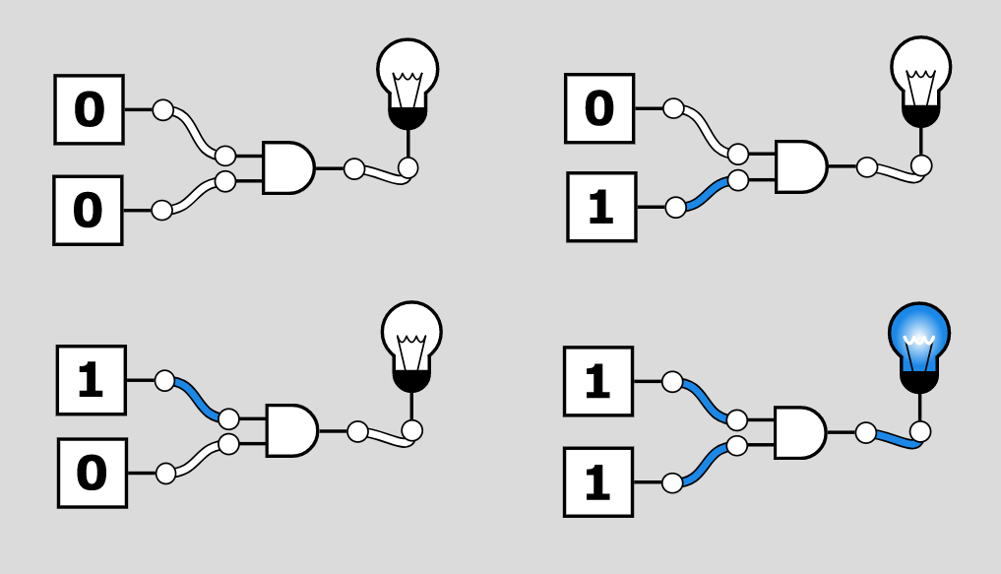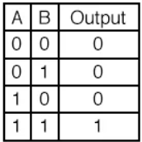

**OR GATE:**

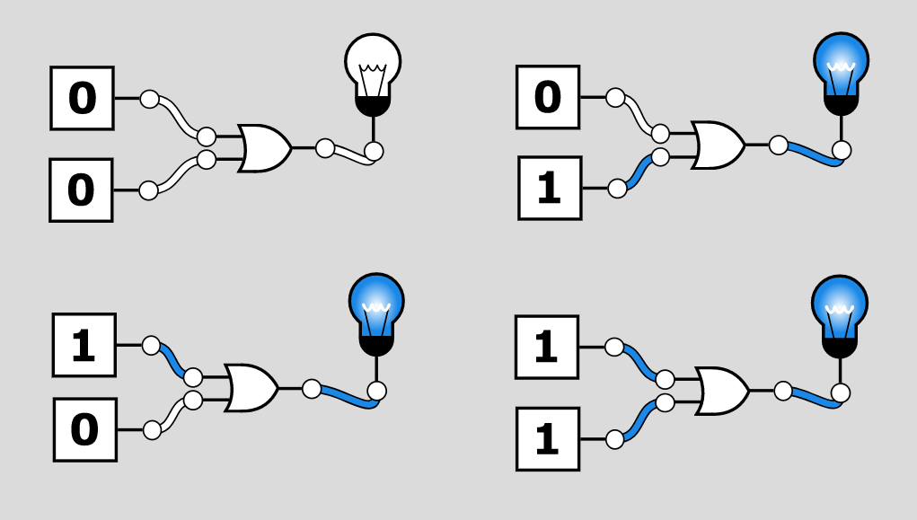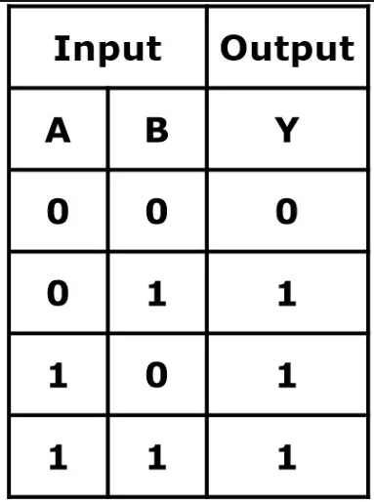

**NOT GATE:**

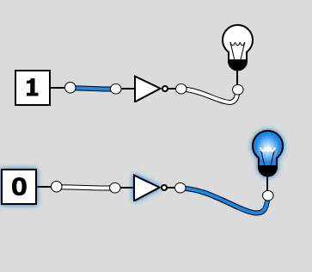 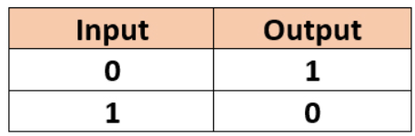

**NAND GATE:**

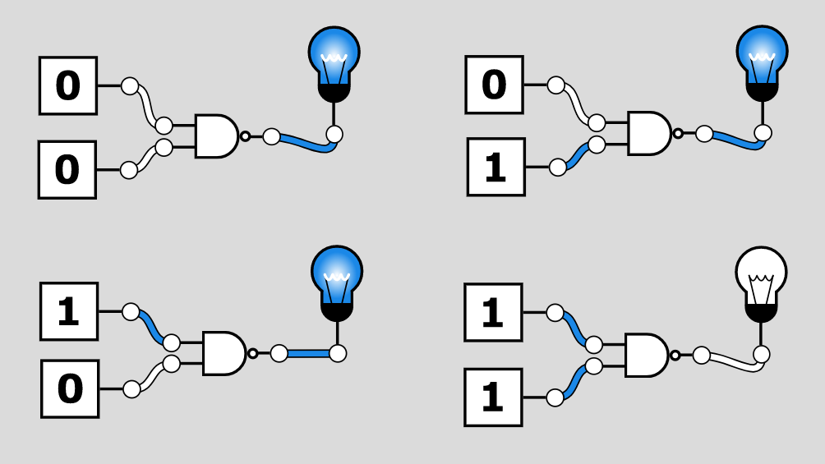 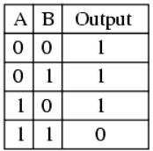

**NOR GATE:**

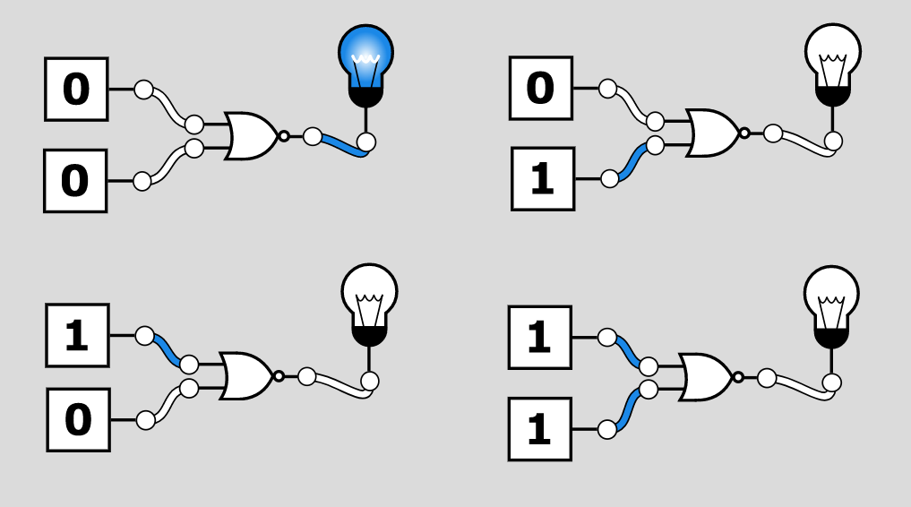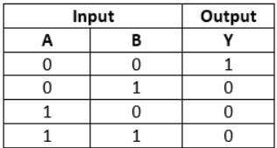

**XOR GATE:**

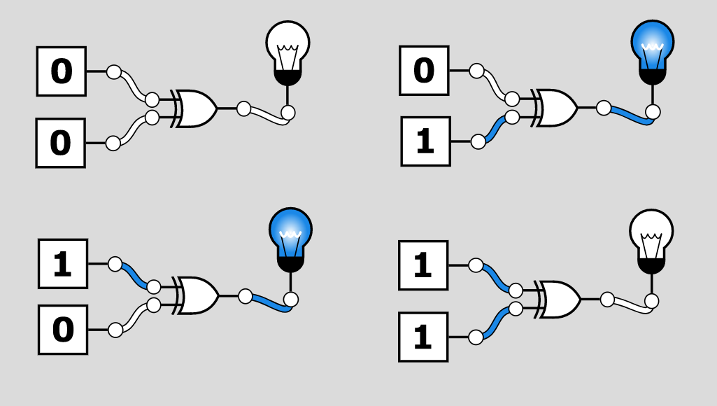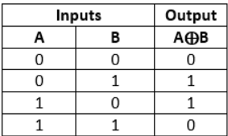

**XNOR GATE:**

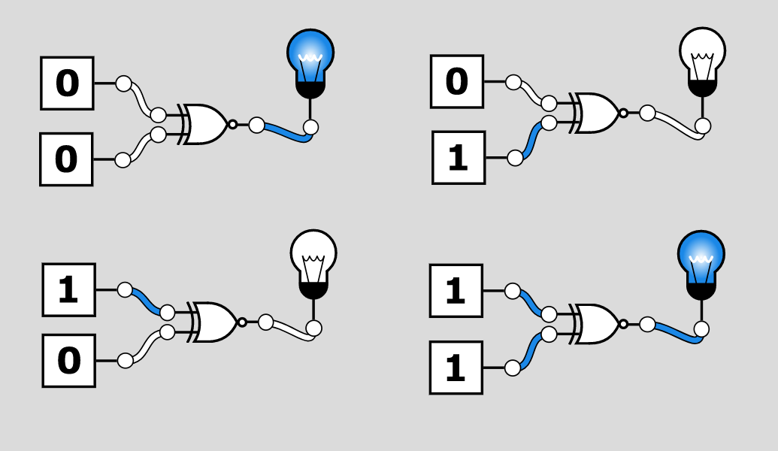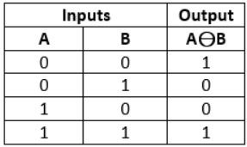

**HALF ADDER:**

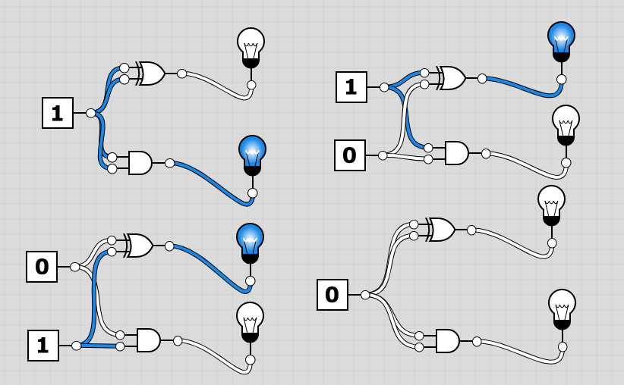

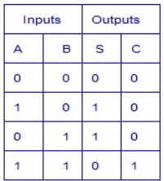

**FULL ADDER:**

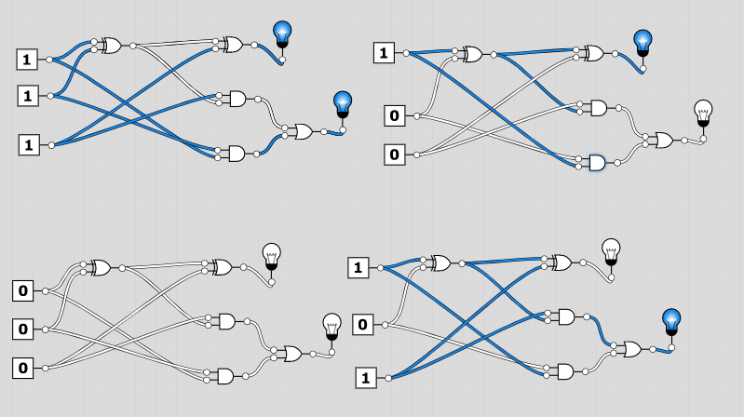

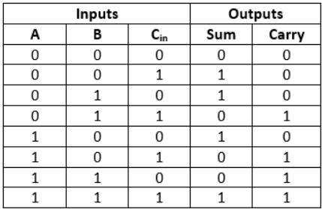

**4:1 MULTIPLEXER**

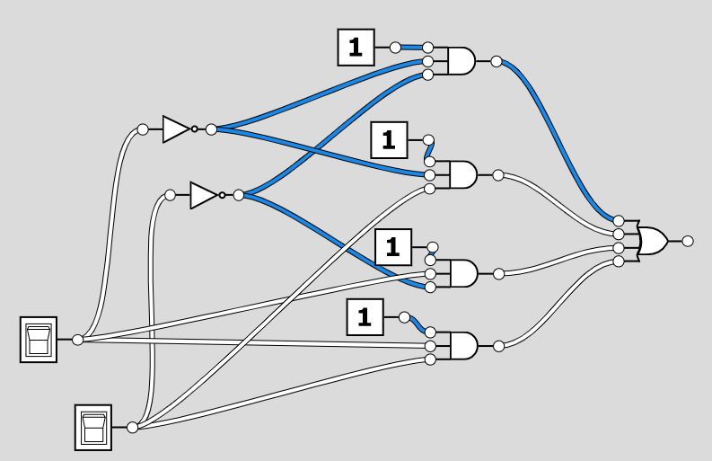

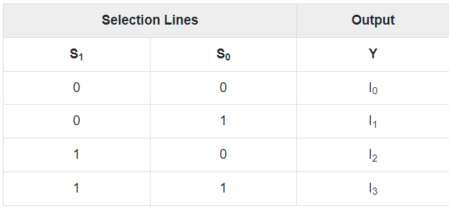

**1:4 DEMULTIPLEXER**

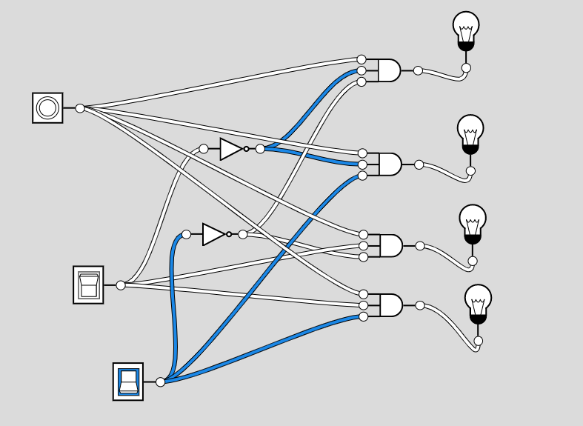

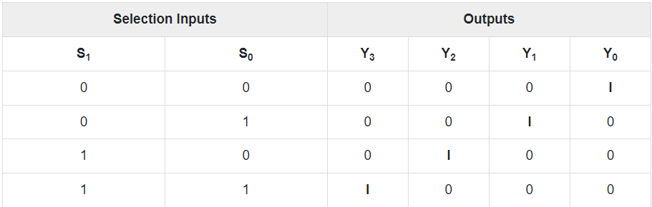

**LAB 3**

**Program for 16 bit BCD addition**

**Input -**

.model small

.data

a dw 8ac5H

b dw 9dc2H

c dw 0000h

d dw 0000h

.code

start: mov AX,@data

mov ds,AX

mov cX,0000h

mov ax,a

mov bx,b

Add ax,bx

jnc GO

inc cx

GO: mov c,ax

mov d,cx

int 21h

end start

end code.

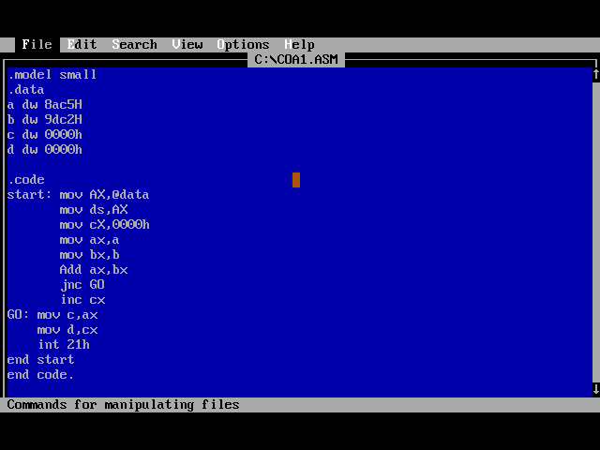

**Output -**

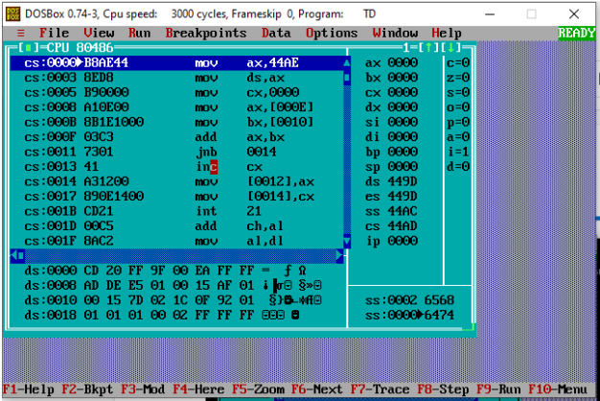

**Dump -**

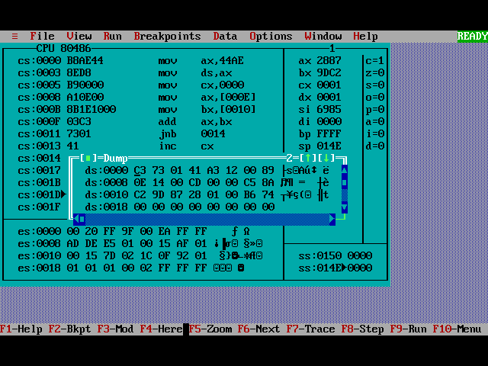

**LAB 4**

**1.Program to count number of 1’s and 0’s in**

**a given 8 bit number**

**Input –**

DATA SEGMENT

NO DW 5648H

Z DW ?

O DW ?

DATA ENDS

CODE SEGMENT

ASSUME CS:CODE, DS:DATA

START:

MOV AX, DATA

MOV DS, AX

MOV AX, NO

MOV BX, 00H

MOV CX, 10H

MOV DX, 00H

UP:

ROL AX,1

JC ONE

INC BX

JMP NXT

ONE:

INC DX

NXT:

DEC CX

JNZ UP

MOV Z, BX

MOV O, DX

INT 3

CODE ENDS

END START

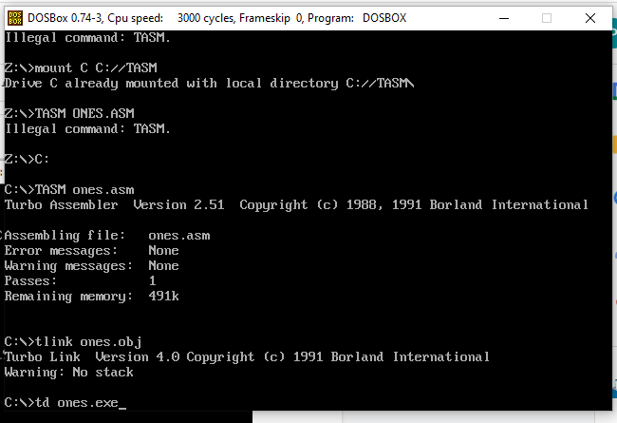

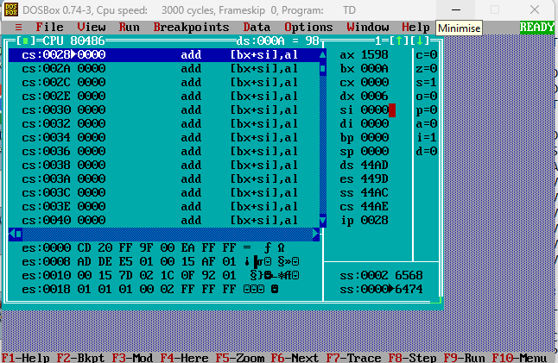

**2.Program to find even odd**

**CODE :**

.model small

.stack 100h

.data

ev db 'Even$'

od db 'Odd$'

.code

main proc

mov ax,@data

mov ds,ax

mov ah,1

int 21h

mov bl,2

div bl

cmp ah,0

je IsEven

mov dx,10

mov ah,2

int 21h

mov dx,13

mov ah,2

int 21h

mov dx,offset od

mov ah,9

int 21h

mov ah,4ch

int 21h

IsEven:

mov dx,10

mov ah,2

int 21h

mov dx,13

mov ah,2

int 21h

mov dx,offset ev

mov ah,9

int 21h

mov ah,4ch

int 21h

main endp

end main

**Execution Of ASM File:**

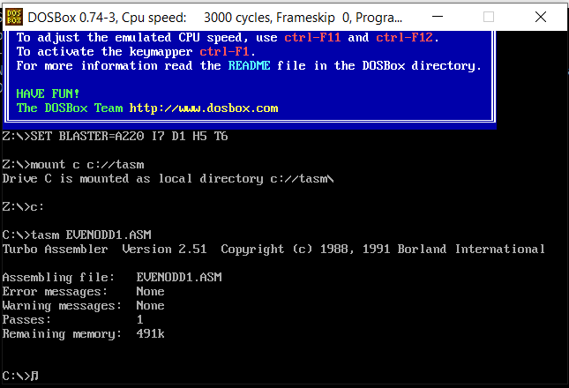

**Initial Output Window:**

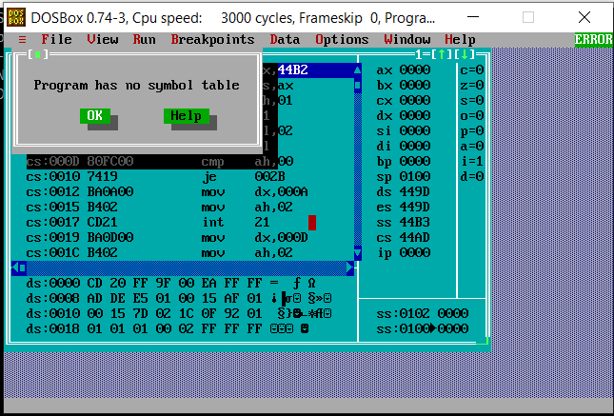

**Code terminated -**

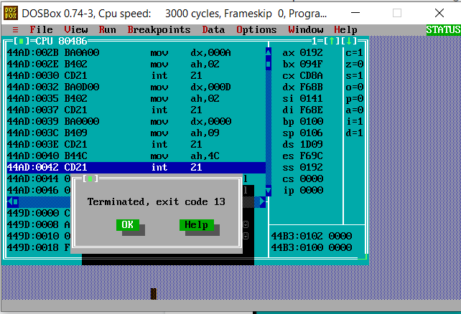

**For even -**

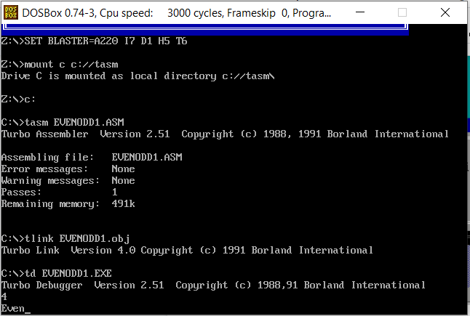

**For odd -**

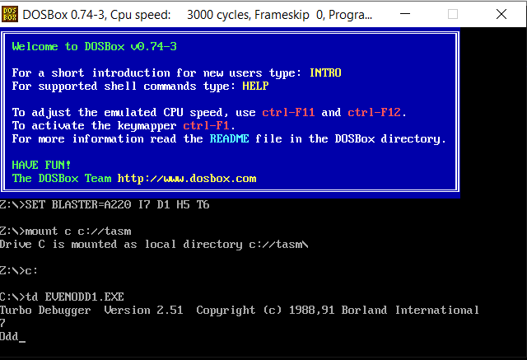

**COA LAB EXPERIMENT NO: 5**

**Check whether a given string is a**

**Palindrome or not.**

**CODE:**

Palindrome final Code:-

DATA SEGMENT

BLOCK1 DB 'MALAYALAM'

MSG1 DB "IT IS PALINDROME $"

MSG2 DB "IT IS NOT PALINDROME $"

DATA ENDS

EXTRA SEGMENT

BLOCK2 DB 9 DUP(?)

EXTRA ENDS

CODE SEGMENT

ASSUME CS:CODE,DS:DATA,ES:EXTRA

START: MOV AX,DATA

MOV DS,AX

MOV AX,EXTRA

MOV ES,AX

LEA SI,BLOCK1

LEA DI,BLOCK2+8

MOV CX,0009H

BACK: CLD

LODSB

STD

STOSB

LOOP BACK

LEA SI,BLOCK1

LEA DI,BLOCK2

MOV CX,0009H

CLD

REPZ CMPSB

JNZ SKIP

JZ NSKIP

NSKIP:

LEA DX,MSG1

MOV AH, 09H

INT 21H

RET

SKIP:

LEA DX,MSG2

MOV AH, 09H

INT 21H

RET

CODE ENDS

END START

**Execution Of ASM File:**

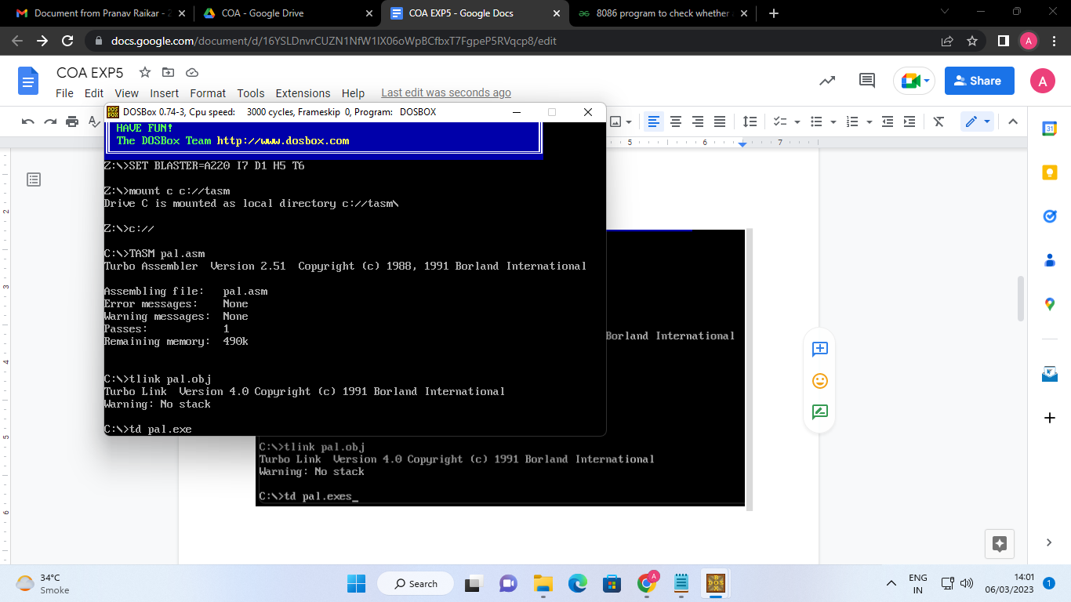

**Initial Output Window:**

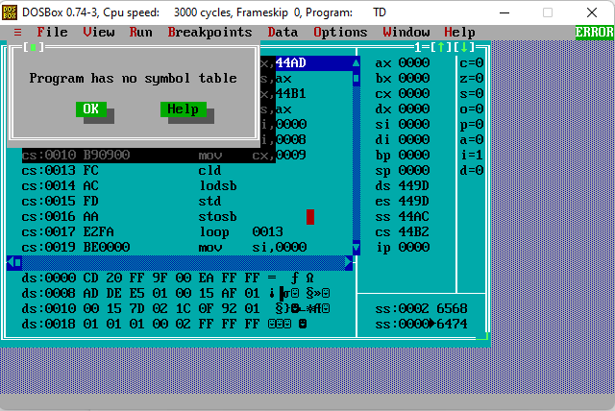

**Output -**

